

**MARKETING ANALYTICS COURSE A.Y. 2023/2024**

**Final Project: Akuna Marketing Analysis**

**Professor:** Massimo Aliberti, Ph.D.

**Work done by:** Ana Foo (V10312), Arina Lopukhina (17169A), Thomas Mayr (12949A), Oumaima El Menni (10651A), John Carlo Piscitelli (12468A), Emile Rahal (10744A), Francesco Scateni (26574A), Daria Shcherbakova (17487A), Salima Tankibayeva (12605A)

**Akuna – Current State Overview**

Akuna S.r.l., an artisan Italian company has been founded in 1999 (its origins date back to 1911), produces five-a-side football boots under the Cinquestelle 1911 brand. Currently, Akuna is a legacy producer of handmade football shoes, which emphasizes their Italian hand-made quality and stability. The positioning established by the company is as follows:

*“The idea that we still want to convey today is that of an excellent artisan product, created from top quality leather, from materials chosen in our footwear district and, above all, the manual skill of the creation process which makes our product unique[1]” (2023 catalogue)*

With the positioning adopted by the company, we can perceive that it intends to occupy a place in customers' minds as a company committed to quality and craftsmanship, resulting in products that reflect the excellence of Italian manufacturing. The company seeks to be recognized as a luxury brand, characterized by comfort, quality, elegance, and exclusivity.

Akuna is mostly present in Central and Northern Italian sport equipment stores, but recently also became available for purchase online. From the internal data generously provided by Akuna management, we can conclude the following:

Covering a market presence in 10 Italian regions (and a total of 121 cities), with Lazio, MUA (Marche, Umbria, Abruzzo), and Emilia-Romagna regions emerge as the top performers in terms of sales for Akuna, with respective total sales values of 152.2K, 129.3K, and 67K. The top three cities in terms of sales are Rome with a total sales value of 101.5K, followed by Parma at 18.7K, and Sona at 16.1K.  
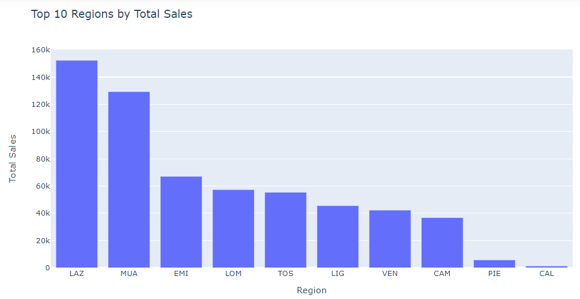

Akuna boasts a network of 144 partners. Among these partnerships, SR 59 stands out as the most successful, contributing significantly to Akuna's total sales with a value of 40.53K. Following closely are ERREA at 24.284K and TUTTOSPORT with a total of 19K in sales.

Overall, by 2023, Akuna has yielded nearly EUR 600K in revenue, having sold over 25K pairs of shoes.

**Problem statement and Project Goals**

***Problem statement:***

Akuna wishes to raise awareness about their brand among potential customers, especially amateur and semi-professional football players. The reasoning behind choosing this target group is because the professional league players have sponsorships with larger multinational corporations, so it is simply inaccessible to Akuna. Ultimately, they would like to expand their market share and begin to utilize the online marketplace platform for orders as well.

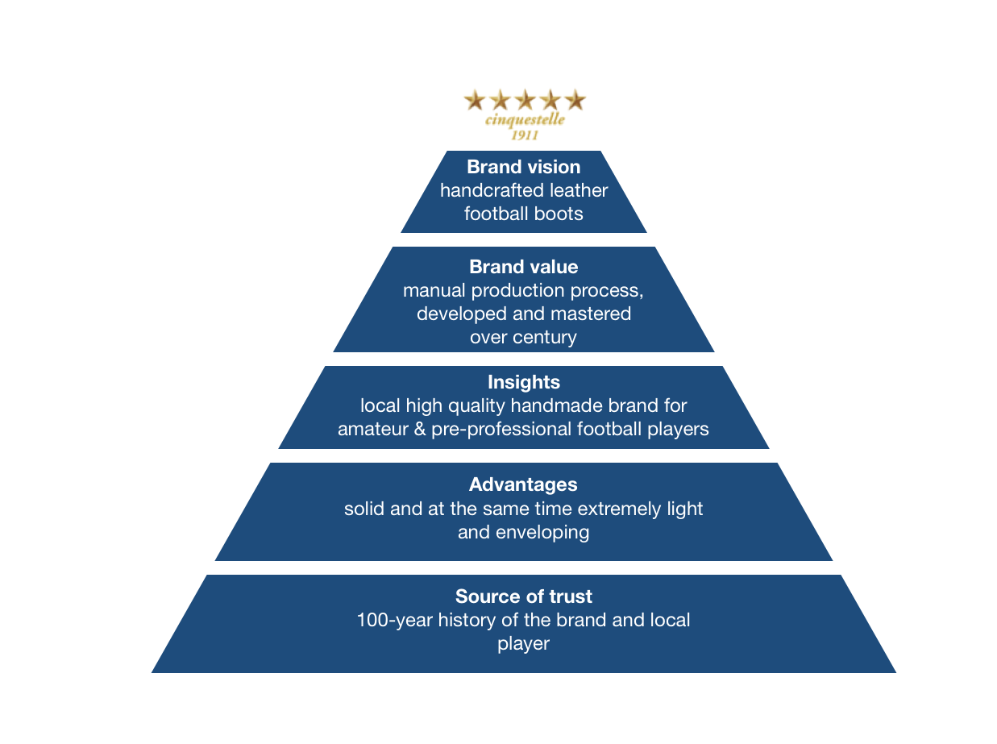

Secondly, Akuna would like to understand which attributes related to football shoes are the most relevant for customers, as well as investigate optimal pricing strategies across different regions.

Project plan and goals:

This project has gathered valuable insights on the Italian amateur football players’ purchasing preferences via the following techniques:

* Market research and competitors landscape analysis
* Customer review analysis
* Attribute importance and purchasing habits survey of two iterations, preceded by an interview with 10 respondents
* Brand awareness analysis
* Customer segmentation via clustering analysis
* Conjoint analysis
* Van Westendorp price sensitivity analysis

The above-mentioned activities allowed us to derive numerous insightful conclusions regarding Akuna’s current standing in the eyes of the potential customers and formulate several proposals for Akuna’s management, including but not limited to:

* Online and offline marketing strategies
* Brand awareness improvement via a social media campaign
* Optimal product pricing

Audience portrait

Before launching surveys or conducting major analysis, we performed brainstorming, considering preliminary research and opinions of amateur football team players. This helped us to define potential customers’ needs, wants, and fears, using the Empathy Map canvas:  
  
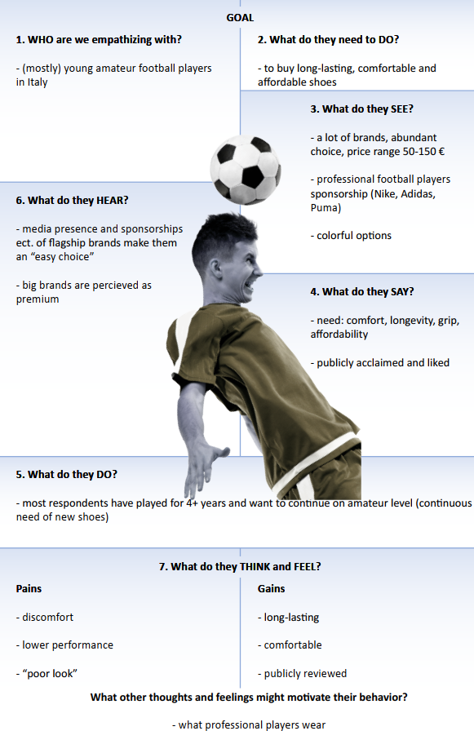

Also, we considered how Akuna’s current value proposition fits the customers’ preferences and expectations, using the Value Proposition canvas:

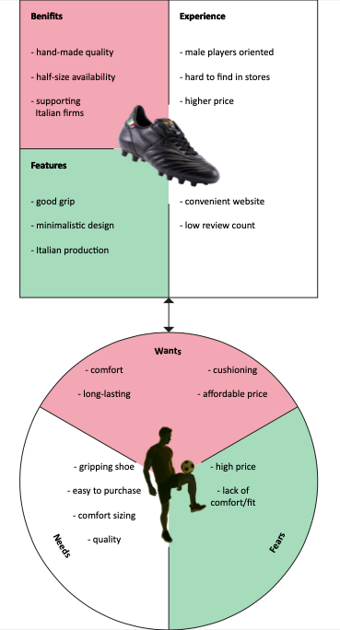

Landscape Competitors

In the competitive analysis, a regional market with two market leaders, Pantofola and Diadora, stands out, creating a challenging scenario for the entry of new competitors. This niche is characterized by the complexity of factors influencing customer loyalty and the formation of a strong connection with the brand. In this analysis, we will focus on Akuna's direct competitors, those targeting the same customer segment. This will provide a better understanding of the competitive environment in which Akuna operates and the associated challenges.

Pantofola d'Oro

As one of Akuna's main direct competitors, Pantofola d'Oro stands out with a strong position in the sports footwear market. The brand is known for its Italian artisanal approach, imparting an exclusive character marked by Italian artisanal tradition. By 1980, Pantofola d'Oro employed approximately 100 staff, producing around 1,500 artisanal shoes per day. In terms of brand awareness, it enjoys prominence through endorsements from various famous athletes. Pantofola d'Oro's brand positioning recognizes the importance of preserving artisanal identity while simultaneously appealing to a wider audience, reconciling tradition and innovation. The product lines encompass not only Football Boots but also Casual Footwear. The range of available sizes reflects the breadth of the offering, with product prices ranging from €90 to €220.

Regarding social media presence, Pantofola d'Oro has a strong foothold. With 19.9 million followers on Instagram, 1,024 followers on the platform X, and active engagement on TikTok, the brand showcases a diverse and engaged audience. The substantial number of followers on these platforms signifies Pantofola d'Oro's strong brand visibility.

Through this analysis, we can grasp that Pantonfola is Akuna's primary competitor. This is attributed not only to its extensive awareness and the similarity of the products sold but also to geographical proximity since they are located in the same city. Additionally, it's worth emphasizing that Akuna was a subsidiary of Pantofola, further highlighting their prominence in the market.

Diadora

Another significant competitor is Diadora, which has been in the market since 1948. The company emphasizes its collaboration with athletes to create products that meet high-performance standards, using more sustainable materials. Diadora's notable aspect, making it one of Akuna's main competitors, is its meticulous attention to production aimed at preserving and consolidating elements of Italian craftsmanship.

The company's portfolio includes not only football boots but also a variety of products, including clothing, footwear, accessories like backpacks, gloves, hats, children's products, as well as specific items for sports beyond football, such as beach volleyball, padel, and running. In the football boots segment, prices range from €100 to €300.

When analyzing social media, we can compare the brand awareness with Pantofola, which has 427 million followers. Although we did not find the profile on the X platform or TikTok, the brand has a substantial presence on all platforms, receiving many positive consumer reviews, highlighting its significant notoriety.

Silei

Additionally, we highlight Silei, another direct competitor based in Florence. Specializing in artisanal football boot production, the company's positioning emphasizes a commitment to delivering products that meet the highest standards of quality, comfort, and performance. In addition to football boots, Silei offers customization services and insoles for sale. While not as widely recognized as Pantofola d'Oro, Silei is acknowledged for its more focused approach. The range of models is more limited, resulting in prices ranging from €75 to €135.

When it comes to social media presence, Silei currently has room for improvement. With only 314 followers on Instagram, no presence on platform X and no reviews on TikTok, we can see that the brand does not have high visibility.

Ryal

Another relevant competitor to mention is Ryal, a company with a consolidated 75-year presence in the market. Its distinctive approach is characterized by craftsmanship, manual skills, quality, cost efficiency, bulk production, and, primarily, an emphasis on customization. The brand's positioning stands out with the "Made in Italy" label, with a special focus on customization and widespread distribution in Italy and internationally. In terms of awareness, the brand demonstrates a strong footprint, with coverage in news and celebrity endorsements. Similar to what we have seen with other competitors, Ryal also diversifies its portfolio to include additional lines such as Casual Footwear and footwear accessories, with prices ranging between 80€ and 140€.

In terms of his social media presence, Ryal is currently facing challenges. The company is not present on popular platforms like Instagram and X, and there are no reviews on TikTok. Ryal's sole reliance on his own website limits his reach and engagement. Global brand awareness appears to be low.

For the competitive analysis, we have created **Table 1** to compare various factors between Akuna and the four most direct competitors. This allows us to identify the key differences.

**Table 1. Competitors’ landscape**

|  |  |  |  |  |  |
| --- | --- | --- | --- | --- | --- |
|  | **Akuna** | **Pantofola d'Oro** | **Silei** | **Diadora** | **Ryal** |
| **Price range** | €80 - €143 | €90 - €220 | €75 - €135 | €100 - €300 | €80 - €140 |
| **Distribution points** | 90 points of sale throughout Italy (northern and central regions) + online sale | Unknown total number of sales points **+** 1 own store in Italy **+** 1 own store in New York **+** online sales | **1** point of sale in Italy **+** online sales | 2314 points of sale throughout Italy **+** online sale | **1** point of sale in Italy **+** online sales |
| **Product portfolio** | 9 models of football boots | 12 shoe model categories of football boot **+** Casual Footwear | 21 models of football boots **+** footwear accessories **+** insoles | 49 models of football boots **+** accessories **+** clothing **+** equipment for other sports | 31 models of football boots **+** casual footwear **+** personalized products |
| **Awareness** | Low | Strong | Low | Strong | Low |
| **Positioning** | Positioning marked by highly manual production  of excellence, quality, from selected materials, knowledge | Recognized for the exclusive character marked by Italian artisanal identity, tradition and innovation. | Positioning marked by products with the highest standards of quality, comfort and performance. | Positioning marked by meticulous attention to the production and preservation of elements of Italian craftsmanship | Positioning marked by craftsmanship, quality, cost efficiency, mass production and, above all, emphasis on customization |

These were the three most direct competitors we associated with Akuna. However, we can also mention indirect competitors that offer alternatives to the company's products. Among them, renowned brands such as Nike, Adidas, Puma, among others, stand out. It is worth noting that, although considered indirect competitors and not targeting the same customer segment, they hold a prominent position in the consumers' mental map when it comes to football boots. Therefore, it is crucial to consider these competitors when developing marketing strategies and positioning in the sports footwear market.

Social media analysis

Akuna relies predominantly on its website for sales. Despite actively posting on Instagram, the brand currently has a low number of followers, with only 239 followers. We noted the absence of a X and TikTok account, but we discovered two positive reviews, indicating a possibility of audience engagement. In addition to the lack of accounts on social media, we can also see the dearth of reviews and interactions from consumers, which highlights yet another factor that demonstrates the brand's lack of notoriety. While the brand maintains an active presence on Instagram and receives positive feedback on TikTok, there are opportunities for expansion.

Reviews analysis

To improve products or services, increase overall customer satisfaction, and inform marketing strategies, it is important to extract valuable insights from customer feedback when analyzing reviews for marketing purposes. One of the important steps in working with reviews is to determine which platforms are used by your clients to post reviews. This could apply to social media, e-commerce websites, review websites, and even brand’s own website. So, in our analysis we found reviews on such platforms as Google Reviews, trustiplot.com, Facebook (AkunaSrl page, 738 followers), and Youtube (Soccer Reviews For You. 819 000 subscribers). These platforms are reliable enough for reviews, however, they present some concerns due to lack of feedback for possible improvements. The accumulated data is presented in the table 2 below.

**Table 2. Review analysis**

|  |  |  |  |  |
| --- | --- | --- | --- | --- |
|  | **Google** | **Trustiplot.com** | **Facebook official page** | **Youtube** |
| **Quantity of reviews** | 6 | 3 | 14 | 25 000 views |
| **Stars** | 5 | 4 | 5 | - |
| **Comments** | *Real leather,*  *comfort of the foot, resistance of the materials and kindness of the producers,*  *Top of the range shoes* (Scarpe top di gamma) | *Soft, high-performance boots, accurate sales and after-sales assistance.*  *They are handcrafted, leather and TOP quality shoes made in Italy! you can't ask for anything more!*  *Excellent product quality*  *Arrived in a few days* (Nov 15, 2023)  (Ottima qualità del prodotto  Arrivato in pochi giorni (15 nov 2023)) | *All top shoes. The quality is excellent. With these shoes you can almost be sure that no one else is wearing them. Here the sole is sewn and you can choose the sole and what is more important, you can choose 2 different sizes for the left and right shoe*. | *Unique, handmade, old school, high quality* |

The problem that arised was the fact that most of the reviews were positive, so we could not see which aspects could be improved. Also, reliability of trust plot reviews was questionable due to the fact that all reviews were written in November 2023. Geographically we could only distinguish reviews between Italians and Germans. Our analysis highlights the importance of using user-generated content to increase brand trust and attract potential customers. However, the current problem is the perception of the authenticity of reviews, which potentially turns off customers. We suggest a multimodal strategy to promote authentic user reviews. We seek to create an authentic culture through increasing transparency, putting incentive plans into place, broadening the range of review sites, and actively seeking out and addressing criticism. The authenticity of user contributions will also be enhanced by verification methods, instructional programs, and streamlined review procedures. Furthermore, a monitoring process and a willingness to respond promptly to suspicious activity are essential to maintaining a cohesive review ecosystem. Through the use of user success stories in marketing materials, we can present real-world examples and encourage other people to contribute their knowledge.

As for the design, as mentioned in the YouTube review, it is more for old school connoisseurs. Whether the business should stick to its traditional aesthetic or change it to appeal to a wider clientele emerges. Examining reviews from rival businesses can give Akuna valuable information. For example, the review for Pantofola d'Oro from the Lockhart Foot blog highlights problems with fitting heel cups, suggesting a possible area for improvement for Akuna. Moving forward, an issue to avoid is interior paint dissolving and discoloring socks, as highlighted in a Reddit review. Also, we can compare YouTube review with the competitor Pantofola d'Oro, as the channel also has review for this Italian company. The review undermines that there is not any heel padding or leather reinforcement to stop overstretching.

In the end, these enhancements mainly aim to build a community of involved customers by creating a reliable environment for user reviews. Our dedication to openness and genuineness will strike a chord with prospective clients, inspiring them to put their trust in us and add to our expanding database of trustworthy evaluations. This will enhance our brand's standing and impact consumer decisions.

Methodology: Survey

In order to have a view on Akuna brand and the market of football shoes in general, a sample survey has been launched. Sample surveys are commonly used in marketing research due to their fast launch and data collection, cost-effectiveness. Moreover, the results of the analysis based on sample surveys are considered reliable and valid due to the rules of sample construction. Therefore, the results of analysis based on data collected through a sample survey can be used in the marketing goals of the company.

Our sample consists of the potential audience of Akuna consumers, amateur or pre-professional football players in Italy, who at least once bought or been gifted with football shoes. Due to the fact that there is no publicly available information about the statistical population according to interested parameters, the sample has been built as a non-probability sample of typical cases, collected with the “snowball” method through Computer Assisted Web Interview (online survey via Google Form). Due to a lack of access to the target group of respondents for the research, the survey has been spread among friends who are interested in football or/and play it, with a request to spread it ahead. Through this approach, the sample size has been achieved to 45 respondents. There are 2 iterations of data collection.

Brand awareness, Customer segmentation

Let us describe the first iteration of the survey. Before asking respondents key questions about football shoes, they have been screened due to engagement in football and the purchase experience (those, who do not play football or/and have been gifted with football shoes have been discriminated against and filtered not to complete the survey). First step, the survey has been launched to assess Akuna’s brand awareness among competitors by amateur or pre-professional football players in Italy. There is a block of questions asking about knowledge about football shoe brands, football players' experience of consuming or not particular brands and intention to consume which. The competitors are used from the competitors' landscape analysis. The next block of questions is dedicated to the segmentation part of amateur or pre-professional football players in Italy, asking questions on the importance of some football shoes’ attributes, lifestyle and socio-demographic status.

Attribute importance

Questions about the importance of attributes (measured with the Likert scale) have been designed from the perspective of gaining insights to test at the second step of the data collection. The study of attributes is essential for guiding product development, analyzing consumer’s needs and differentiating offerings in the market. Effective marketing analysis relies on highlighting key attributes to improve the overall company strategy. This aspect becomes particularly relevant in market segmentation, where consumers are categorized based on shared characteristics.

The selection of attributes is a crucial step in determining the effectiveness of the segmentation, and later conjoint analysis. In the context of our analysis on Akuna, and of football shoes, we have extracted a series of attributes, which could influence consumers in their decision, from various external sources, such as articles, shoes reviews and other YouTube videos, and from brainstorming with amateur football players. We have come up with an initial list of 35 attributes, both tangible and intangible, which represent elements on which football players base their purchasing behavior when they are buying new football shoes.

**Table  3. Initial attributes for testing**

|  |  |  |  |  |  |
| --- | --- | --- | --- | --- | --- |
| Role on field (goalkeeper, defender…) | Comfort | Grip | Type of surface (synthetic, grass…) | Materials (Leather/Synthetic) | Ankle Support |
| Style of Play (Skill, speed) | Different foot shape (Narrow/wide foot) | Insole quality/materials | Ease of putting on/Removing | Flexibility | Shoe weight |
| Laces/No laces | Studs shape/size | Possibility to remove studs | Style/Design | Upper/Outer shape | Brand Image (sponsors…) |
| Cushioning | Personalization Options | Playing Level (amateur/professional…) | Breathability | Washability | Sizing |
| Waterproof | Shock Absorption | In store experience/Availability | Performance in dry/wet/muddy field | Insole replacement possibility | True to size |
| Orthopedic Insole Compatibility | Build quality | Brand reputation/word of mouth | Responsiveness while running |  |  |

These potential attributes capture a variety of consumer preferences and represent the key features and elements on which they base their purchasing decision, depending on their personal needs. Having such a wide list of attributes, however, is detrimental to the analysis, therefore, they underwent further selection and trimming in order to select those attributes that better represent the elements and the features which are relevant to the consumer, furthermore, we noticed how there were instances in which some of the selected attributes included others, this offered room for further attributes trimming. We narrowed down the attributes through quasi-structured interviews with amateur football players, in particular, we asked 8 respondents to pick, out of the 35 attributes above, 10 attributes that would influence their purchasing decision.

**Table  4. Attributes for the survey**

|  |  |  |  |  |  |  |  |  |  |
| --- | --- | --- | --- | --- | --- | --- | --- | --- | --- |
| Comfort | Grip | Materials (leather, synthetic…) | Ease of putting on/removing | Different Foot Shape (Narrow/wide foot) | Flexibility | Ankle Support | Design | Build Quality | Sizing |
| Comfort | Grip | Materials (leather, synthetic…) | Ease of putting on/removing | Different Foot Shape (Narrow/wide foot) | Flexibility | Ankle Support | Design | Build Quality | Sizing |
| Comfort | Waterproof | Materials (leather, synthetic…) | Ease of putting on/removing | Different Foot Shape (Narrow/wide foot) | Brand Image | Cushioning | Personalization options | Type of surface (grass) | Breathability |
| Comfort | Grip | Materials (leather, synthetic…) | Studs shape/size | Different Foot Shape (Narrow/wide foot) | Flexibility | Cushioning | Shoe weight | Type of surface (grass) | Sizing |
| Comfort | Waterproof | Washability | Ease of putting on/removing | Different Foot Shape (Narrow/wide foot) | Flexibility | Cushioning | Shoe weight | Build Quality | Responsiveness while running |
| Comfort | Grip | Materials (leather, synthetic…) | Insole quality/materials | Different Foot Shape (Narrow/wide foot) | Breathability | Waterproof | Shoe weight | Build Quality | Sizing |
| Comfort | Laces/No laces | Materials (leather, synthetic…) | Playing level (amateur, professional) | Different Foot Shape (Narrow/wide foot) | Flexibility | Upper/Outer shape | Design | Build Quality | Sizing |
| Comfort | Grip | Type of surface(synthetic/grass) | Ease of putting on/removing | Brand Image | Flexibility | Cushioning | Playing style | Build Quality | In store experience |

The above attributes, selected by each respondent without any particular order, highlight the factors which matter the most to them in the choice of football shoes.

The second part of the data collection is dedicated to testing pricing positioning and attributes’ combination importance of the product. Thus, this interaction of the survey also consists of 2 blocks: Price Sensitivity Meter (according to Van Westendorp’s approach) and conjoint tests.

Conjoint analysis

Conjoint analysis helps companies develop sharper product definitions by identifying product features that will appeal to customers. It helps products to view them as bundles of attributes. The attribute has many options and levels, a bundle consists of one chosen option or level of each attribute. In conjoint analysis, we can use data about customers’ overall preferences for a selected number of product bundles and decompose them into the utility values that customers assign to each level of each attribute. We need to ask respondents to provide their preferences for a carefully selected set of product bundles. Potential customers rate the bundles to show their degree of preference for each, trading among attributes.

In order to perform a conjoint analysis and get an idea of the preferences of potential customers, we collected survey data from a total of 24 respondents. Each respondent had to choose five times between sets of three bundles each. Every bundle was unique and consisted of a combination of four attributes: *“Design”, “Price”, “Size”, “Quality”*. The attribute “Size” had two levels while the rest all had three possible levels.

**Table 5. Conjoint analysis design**

|  |  |  |  |  |
| --- | --- | --- | --- | --- |
| **Product** | **Attribute** | **Levels** | | |
| Football shoes | Design | Full customization options (colors and graphic details on shoes) | Availability of different colors | No possibility to influence design |
| Price | 75 | 105 | 140 |
| Quality | Handmade with natural materials | Mass produced with natural materials | Mass produced with synthetic materials |
| Size | Full size | Availability of half-sizes | |

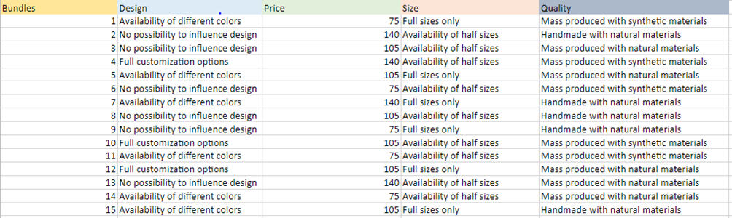

Respondents had to compare the three given bundles and decide for one specific bundle, meaning ranking the alternatives or giving a point-based preference for each bundle was not possible. Furthermore, it is important to note that each respondent had the same sets of bundles and, due to the specific setup, respondents could not compare all possible bundles at once. In total 15 different bundles were included in the survey (54 unique bundles were theoretically possible by combining attributes).

Ideally, the survey would have asked for either a ranking or point-based preferences of a randomized set of bundles for each respondent, but due to the technical limitations of the survey tool this was not possible, therefore this specific survey design was chosen.

Because of this relatively uncommon data structure for conjoint analysis, unfortunately many popular conjoint tools and packages could not be used. Nonetheless, the data still allowed us to infer information about preferences from the respondents’ choices. After careful consideration and consultation of the literature in the field[2], a multinomial logit regression model was chosen for this process.

The multinomial logit model takes into consideration that the dependent variable is multinomial = a choice from among multiple options. The resulting coefficients can be used to infer preferences and estimate potential market shares. To estimate the model dummy variables were constructed for every attribute level. The baseline was a shoe with the following attribute levels: “No possibility to influence design”, “140€”, “Full sizes only” and “Mass produced with synthetic materials”. This baseline was chosen because logically it should be the most unappealing shoe. In theory, every possible change in the attributes should be an improvement in the likelihood of making the choice for this shoe. As we will see this basic intuition will be confirmed in the analysis.

Van Westendorp’s Price Sensitivity Meter

As Akuna’s shoes fall on the higher end of the price range of the brands we observed, it would be beneficial to dive deeper into the consumer’s preferences as well as financial capabilities when it comes to picking a new pair of cleats. We have created an additional survey in order to gather data for the Van Westendorp’s Price analysis, asking direct questions such as ‘what is a ‘stealing price’ for a pair of cleats’ and ‘what price is exaggerated’. The results will give us a valuable insight into whether Akuna’s online marketplace prices correspond with what customers are willing and able to pay. This information could also be combined with additional socio-demographic data, which could help us draw further conclusions about customer’s purchasing habits via descriptive statistical approach or additional ML models, such as regression or decision trees.

Data analysis on Surveys

Portrait of the respondents of the first survey

First of all, it is important to look at the portrait of the respondents, although the data is biased in terms of socio-demographic characteristics due to the method of data collection. The age of respondents varies between 17 and 32 years, with the majority between 21 and 24 years old, with most high school graduates, followed by bachelor's and master's degree holders, and a medium income. They play amateur football and few of the respondents have semi-professional football experience, with more than 10 years of playing football. Most of the respondents want to stay in amateur football, some are undecided, and a few aspire to become coaches or plan to stop playing soon. People in the sample prefer to watch football matches at home (TV or streaming) or attend live matches in stadiums.

Footballers consider replacing football-related items when they are too worn out, and their purchasing choices are mostly not influenced by a lack of reviews on the items they are looking for. Those, who are buying shoes more frequently might be less affected by the absence of reviews, due to clearer idea of their preferences or are less concerned about reviews due to their regular shoe replacement cycle, compared to those who purchase less often and those people might prioritize the presence of reviews as guidance for their purchases. Respondents are not current Akuna users, but some show interest in trying the brand.  
  
  
  
***Brand Awareness***

One of the objectives of the marketing analysis is brand awareness. The main focus is on consumers’ answers on Spontaneous Brand Awareness (all brands), Aided Brand Awareness, Usage of the brand at least once, Current usage of the Brand, Intention to use the brand in the future and the strong intention not to use the brand in the future.

Among competitors, Akuna shows the need for more spontaneous and aided brand awareness. Diadora, Kipsta and Pantofola d'Oro show low spontaneous brand awareness among consumers, while aided brand awareness is almost close to big players. In other words, when semi-professional football players need to think about boot brands, Diadora, Kipsta and Pantofola d'Oro would come to mind not immediately, but with help. The main market players show high spontaneous and aided brand awareness, meaning that these brands are top of mind for almost every respondent from the sample.

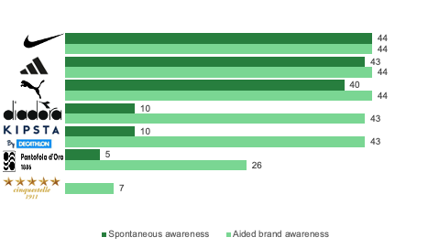

Big market players also show significant numbers of those who tried the brand at least once and stayed with the brand in the market. Despite the loyal consumers among Nike and Adidas, the current usage is not the same. In other words, even if the brand is well-known there is still an option to lure some clients. For the Kipsta and Diadora brands, there is evidence that some respondents have tried the boots, but none has continued with the usage of this brand. Despite the low trial base of Pantofola d'Oro shoes, some respondents currently remain with this brand. Akuna has a critically low customer base in the sample, which could be considered as the consequence of low brand awareness.

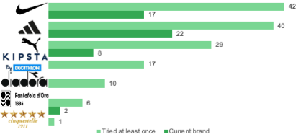

Adidas and Puma show low anti-intention to use in the future the brands, meaning that consumers who have tried the brand’s boots once or currently use them are satisfied with the products provided, however, Adidas shows higher intention to use in the future, strengthening positions on the market. Akuna, Diadora and Rayal brands show the lowest desire to use the boots from these brands in the future and share almost the same points for the rejection of these brands in the future. However, this parameter is not far from Nike, the leader of the market. Pantofola d'Oro brand shows the interest of potential customers and attracts new consumers to consider the boots in the future.

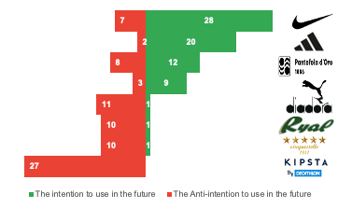

Considering conversion from awareness of the brand to trying the brand's shoes, and from trying the brand's shoes to the usage of the brand's shoes there are absolute leaders of the market Addidas and Nike. These key and big players show good retention of clients and attractiveness to new customers. The potential to attract loyal customers is shown by Pantofola d'Oro. The client base might be not enormous, however, current clients are aware of the brand and would not switch to another one easily. There is a group of weak brands: Kipsta, Diadora and Akuna. The first two sports brands show more awareness than Akuna. However, all of them could not be considered as desired brands for new customers and those, who have loyal clients. Instead, Akuna shows critical unattractiveness for clients with low visibility on the market. Also, Diadora almost has the same position on the map, both brands are from a high-price segment, but with a low potential to succeed in the market.

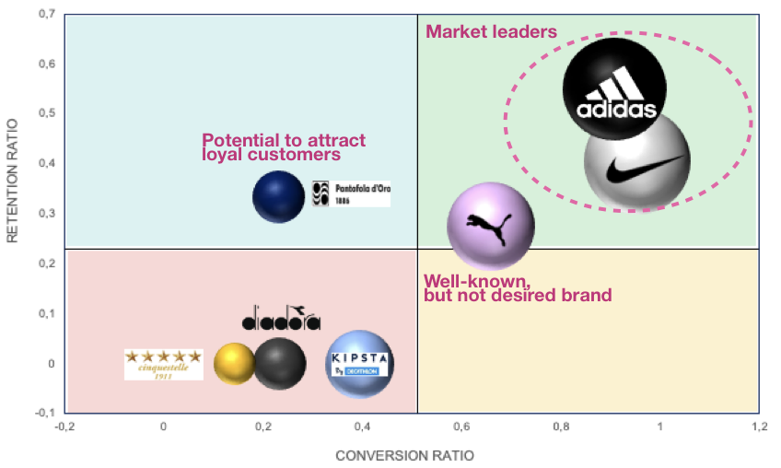

Brand awareness analysis shows that potential customers of Akuna are not aware of the brand. Thus, Akuna has to increase its visibility and attract new customers in order to expand its conversion rates. Even if the customer knows the brand, there is low conversion to the step of usage. There are some barriers for potential consumers not to consider the brand, however, the anti-intention of use shows the opportunity to appeal to new clients and convince them to buy Akuna. In this case, better media performance of Akuna may help with this goal. Another possible barrier to attracting customers could be the price, since from the conversion and retention ratios the brand is close to direct competitor Diadora, which is in the high-price segment of the market. To test this hypothesis further analysis has been performed.

Customer segmentation (based on product attributes)

Principle Component Analysis

To cluster and group our respondents, who are both current customers and potential customers, we rely on the features obtained from the answers about their preferences regarding various attributes of football shoes. These attributes include:

1. Shoe Customization Options
2. Colors Variation
3. Handmade
4. Easy to Put On/Off
5. Grip on Field
6. Sponsorships with Football Players/Teams/Schools
7. Premium Brand
8. Size Variation and Perfect Fit (Half Size Option)
9. Brand Awareness
10. Natural Materials (e.g., True Leather)
11. Low Price

These features are important to categorize and understand the distinct preferences of our respondents, guiding us in the process of creating meaningful clusters for targeted decision-making. By creating these clusters based on the different attribute preferences, you can tailor marketing messages, promotions, and product offerings to cater specifically to the unique needs and desires of each customer segment, thereby enhancing customer satisfaction and loyalty.

But before we begin with clustering, we need to make some dimensionality reduction, which needs the application of Principal Component Analysis (PCA) on the product attributes. To select the optimal number of Principal Components, the scree plot tells us to look at the elbow curve where the variance starts to level off. In this instance, we opted for 3 PCs, capturing 69% of the data's variance.

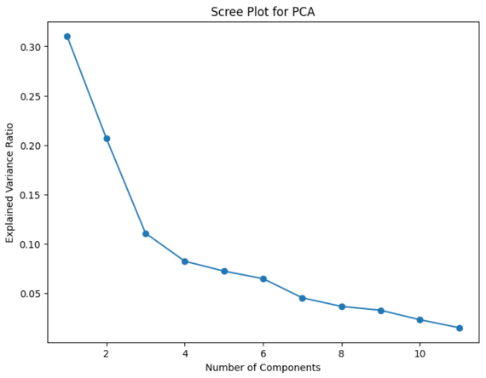

We employed PCA with three components on the scaled attributes data. The resulting principal components were integrated with the attributes to generate the loadings of each attribute on the identified principal components.

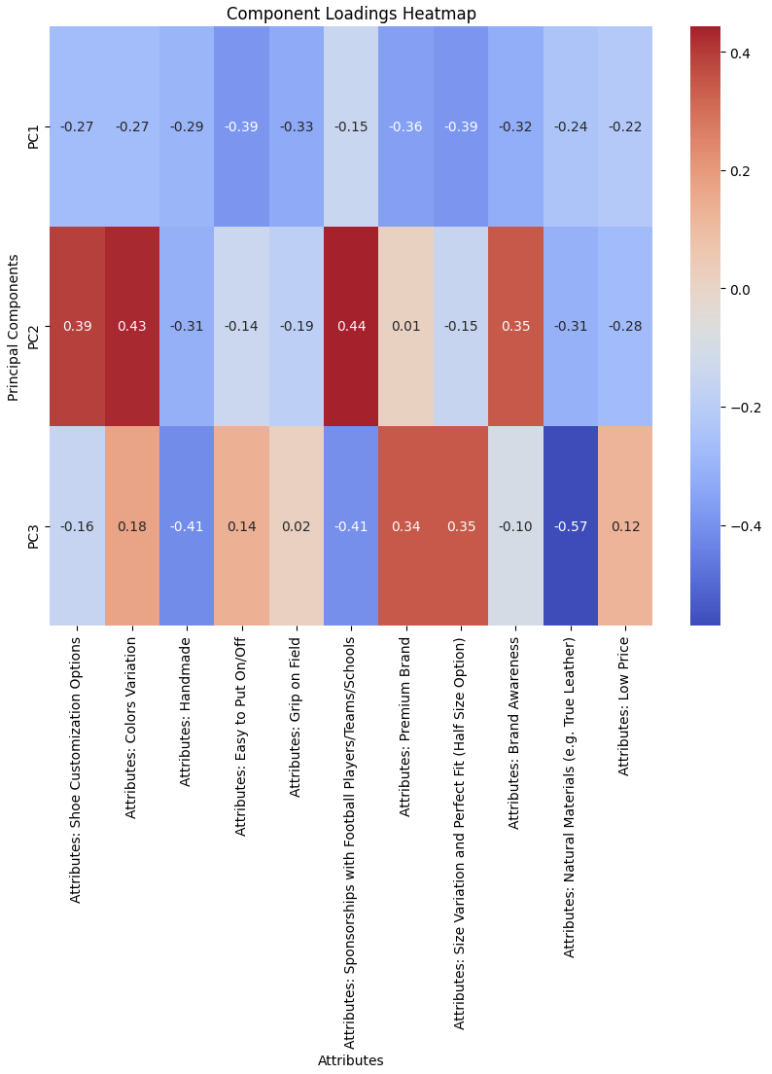

The loadout analysis becomes important in seeing how each component signifies specific attributes. The heatmap visualization of component loadings represents the relationships between attributes and principal components. Warmer colors indicate stronger connections, and the numeric annotations showcase the magnitude of these associations. This analysis allows us to discern which attributes play a significant role in shaping each principal component, aiding in the interpretation of underlying patterns and contributing factors in the dataset.

Being able to understand the loadouts also makes us confident in knowing which attributes are more important, so we can focus on a smaller number of them which helps with other analysis.

Essentially, the loadout analysis enhances our comprehension of the underlying structure in the data, helping in the interpretation of clusters and the identification of the impactful attributes within the product preferences.

For example, looking at the first 2 principal components (also the ones that will be plotted), we can understand the characteristics of the component:

**PC1**: It's a mix of stuff that makes shoes practical (easy to use, good for playing) and things that make them special (handmade, unique sizes).

**PC2**: This one's about how the shoes look and their brand image. It's tied to different colors and materials, and it's also about how people see the brand itself.

***Clustering using K-means***

Now we can cluster using the K-means algorithm on the PCs that we got to see the different clusters of customers using the reduced dimensionality of the attributes. Before anything, we need to specify how many clusters we need to have, this choice isn't random that's why we used the elbow method that evaluates the inertia values for different values of K and identify the point the point at which the rate of decrease in inertia starts to diminish, forming an "elbow" in the plot.

As we can see from below the optimal number of clusters will be 4 clusters because selecting the number of clusters involves finding a balance between explaining variance in the data and avoiding overfitting. The point where diminishing returns set in suggests that adding more clusters may not provide substantial improvement in capturing the underlying structure of the data.

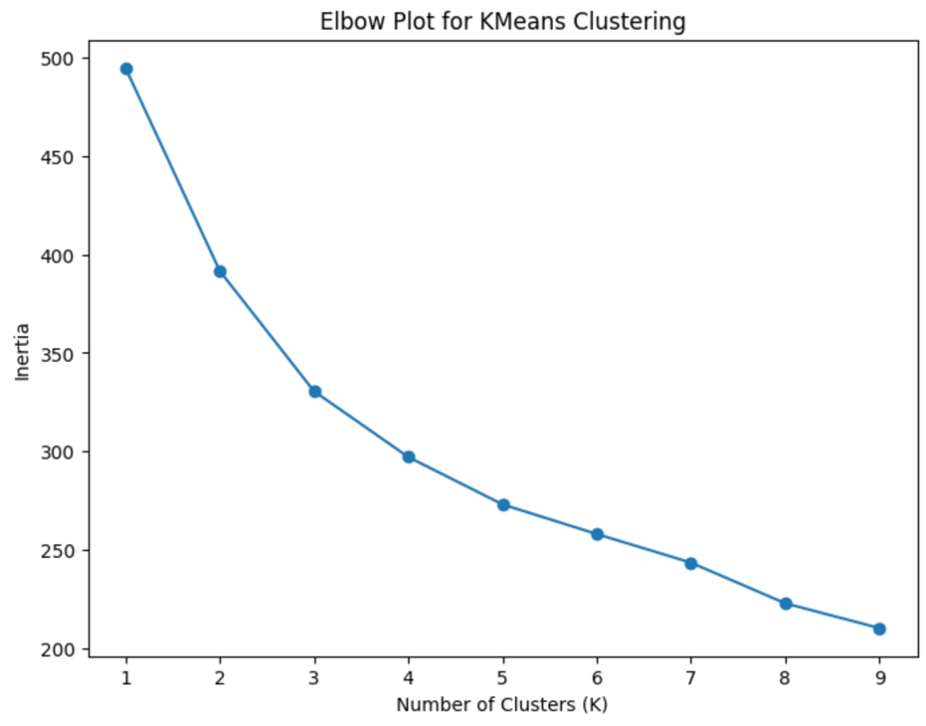

Also, a cluster count of 4 is expected to provide a meaningful segmentation that aligns well with potential customer segments in our analysis. Our goal is to identify distinct customer segments that can guide personalized marketing strategies and enhance the overall customer experience. Considering our business context, choosing 4 clusters strikes a balance. It allows us to create meaningful customer segments without overcomplicating our marketing strategies. With 4 clusters, we anticipate identifying key customer groups, such as performance-oriented customers, casual players, enthusiasts looking for the latest styles, and those focused on economical options.

We plot the 4 clusters on the axis of the first 2 components (2D) to make it easier to interpret the clusters, also we can see that we have intersections between the clusters which means that certain data points share common characteristics or similar behaviors.

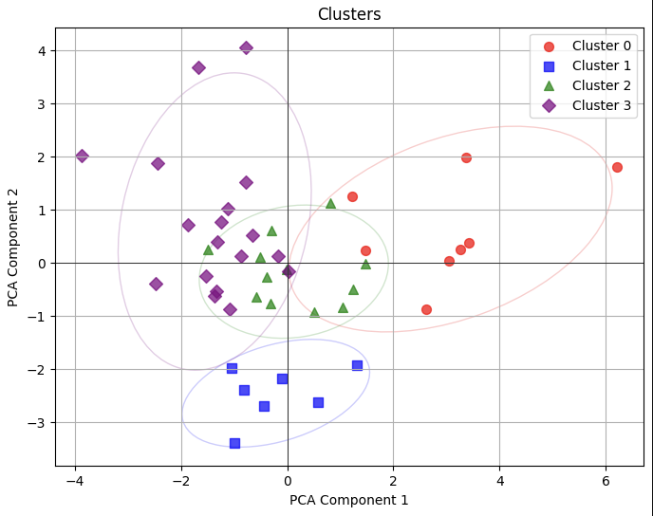

To be able to understand what each cluster’s characteristics are and make it more realistically interpretable we should understand the influence of an attribute (based on the mean value) across the clusters so we can make a pattern of the preferences of each cluster of customers. This approach aligns well with centroid-based clustering algorithms, such as K-means, where the mean serves as a representative location for each cluster in the feature space. It also makes the process computationally efficient and less influenced by outliers. So, when we calculate the mean value of each attribute and try to understand its values, for sure using plots like the ones below, we can understand how each cluster interacts with the attribute of the product.

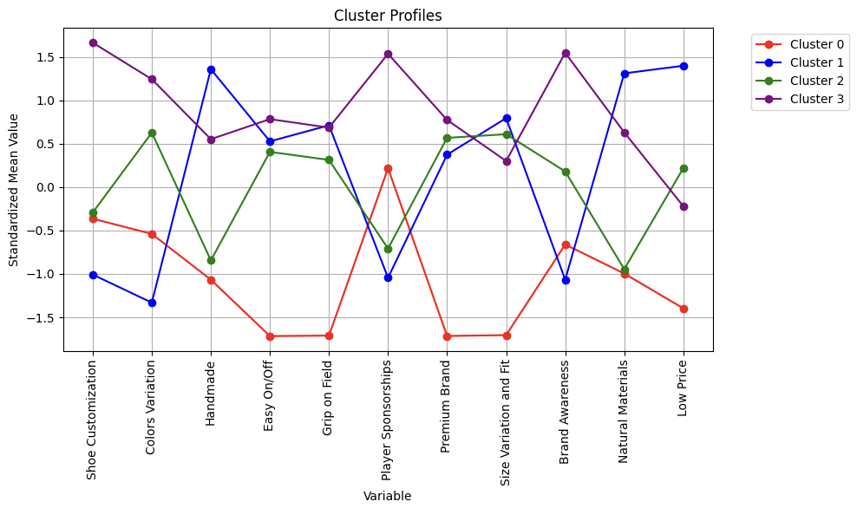

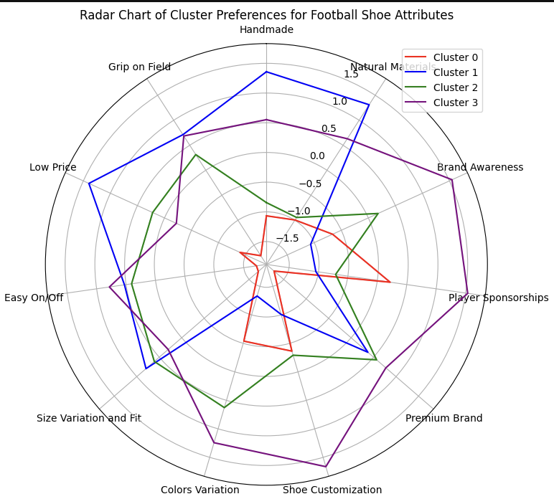

We look at the clusters in the plots to see how the values are changing from cluster to another showing the diversity and the obvious differences in the preferences.

In **Cluster 0**, we find individuals who are basic and non-naggy, not tending towards any specific feature or attribute. They prefer normal options without a focus on customization, premium brands, or specific qualities. To aim to this group, emphasize low prices and simple features in marketing, run sales or discounts on essential items they're likely to buy, and make buying straightforward with clear prices.

**Cluster 1** consists of quality-seeking and convenient individuals who prefer higher quality, handcrafted, and natural items. They value a wide range of choices in sizes and convenience in usage, seeking products that offer good performance without being too expensive. To target this cluster, advertise products as top-quality and made from natural materials, make returns and exchanges easy, and sell special high-quality items as exclusive choices.

**Cluster 2** is composed of practical and budget-conscious individuals with less inclination towards handcrafted or natural products. They might prefer items with a moderate range of sizes available at affordable prices, valuing products that offer reasonable functionality without high costs. For this cluster, offer deals like "Buy 2, Get 1 Free" or discounts on big purchases, advertise products as durable and great value for money, and give rewards or discounts to frequent buyers.

**Cluster 3** is made by premium and brand-oriented individuals. They prefer quality customizable luxurious and recognized brands, seeking products associated with players/teams that offer customization and varied options. There's a balance between product usability and a preference for well-known, premium brands. Strategies for this cluster include partnering with famous people for endorsements, releasing limited editions or unique collections, and showcasing products on social media with celebrities or in special editions.

This analysis serves as a valuable tool for Akuna to gain insights into the preferences of their existing customers. By understanding these preferences, Akuna can make their product offerings better align with the specific needs and desires of their customer base. While this analysis could be extended to include additional features, the focus on attributes provides an important understanding of the respondents' preferences. This knowledge helps Akuna to enhance their product portfolio to perfectly match their customers preferences.

Portrait of the respondents of the second survey

The survey's second iteration has a sample size of 24 and a similar sample structure. Overall, an average respondent is a native Northern Italian in their late 20s, a full-time worker, and has medium financial capabilities according to their own assessment. They typically pay between 50 and 120 EUR for a pair of cleats which they buy every 2-3 years.

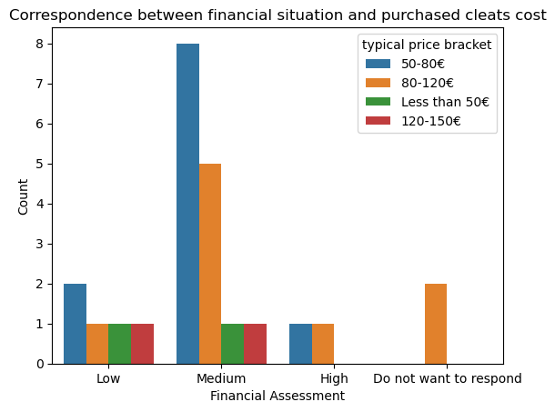

They prefer to shop in person and are adamant about never buying a pair of cleats from an unknown brand without trying them in real life. A way around this could be advertising an easy way to refund (and/or replace) a product purchased online in case of poor fit, which could incentivize new customers to try the product regardless of being unfamiliar with it, as it would cost them nothing or very little in case they would like to exchange or return it. Lastly, the direct questions (not Conjoint bundles), they do not seem to seek out for hand-made quality, but they tend to believe that Italian-made shoes are better than the ones produced abroad.  
  
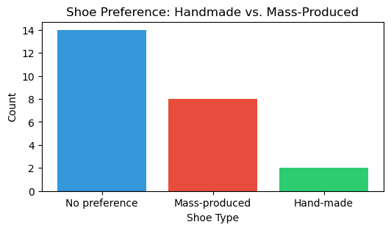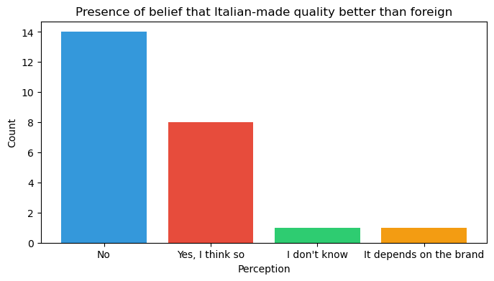

To finalize the pricing analysis, we used the Van Westendorp method which required asking the participants to indicate a price they would consider suspiciously cheap, a bargain price, an expensive but reachable level, and an out-of-limit price. The price sensitivity meter suggested the optimal price to be 60 EUR, with the possible range of 60 to 100 EUR. A higher price level is very likely to result in participants eliminating the option.

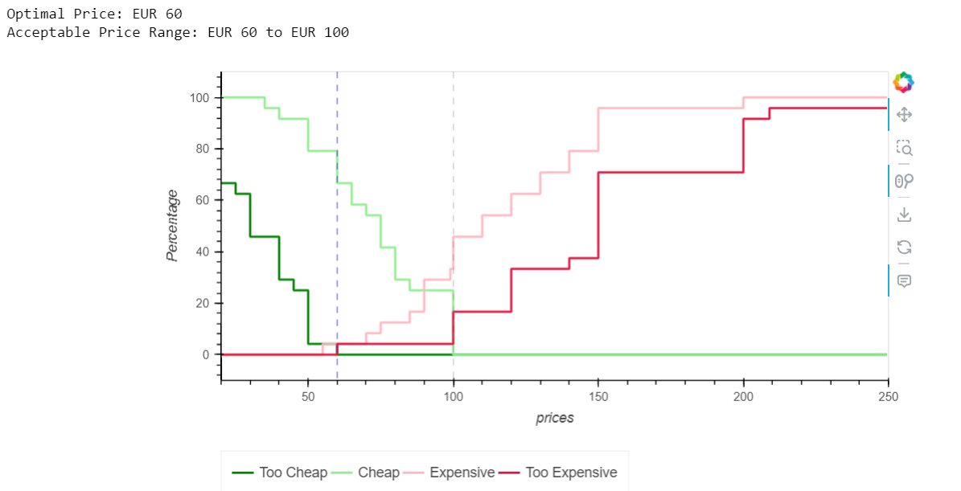

Conjoint Analysis

The summary output of the estimated model can be seen below. Looking at the coefficients, which represent the log-odds of that particular attribute level on the choice, we can determine which features have the most impact on the likelihood of choosing a shoe. The attribute “Design” seems to have the least influence overall on choosing a shoe. The coefficients of “Availability of different colors” and “Full customization options” both have a relatively low effect compared to other features and are not statistically significant. In contrast, the attribute “Quality” has the greatest impact: moving from a shoe “Mass produced with synthetic materials” to “Mass produced with natural materials” or even “Handmade with natural materials”, ceteris paribus, seems to be greatly valued by the survey respondents. Furthermore, lowering the price from the baseline 140€ to 75€ and even just to 105€, again keeping other factors equal, also improves the likelihood of choosing a particular shoe significantly. When it comes to Size “Availability of half sizes” has a lower but still statistically significant (p < 0.05) effect.

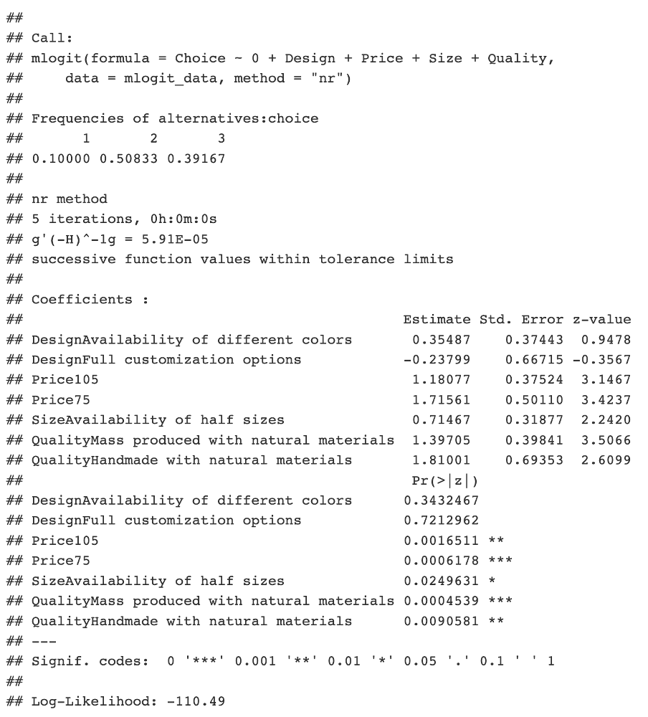

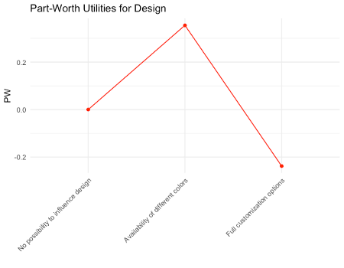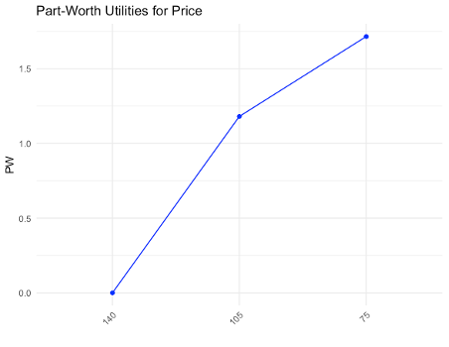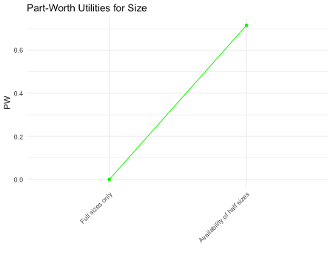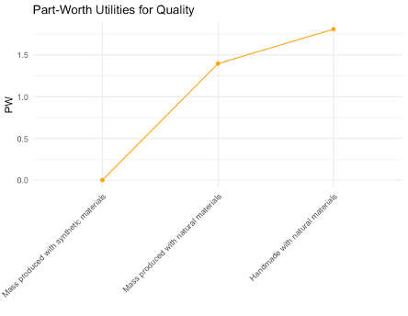

Furthermore, we predicted the market shares for the bundles surveyed considering an hypothetical scenario where only football shoes available on the market were those proposed in the survey. Below the best 5 and the worst 5 bundles, respectively.  
   
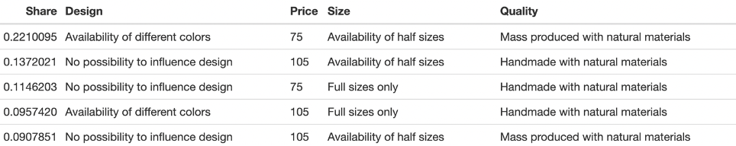

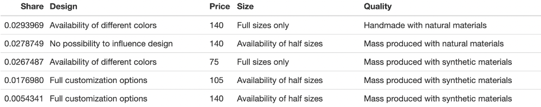  
  
We, then, predicted the market share for all combinations possible. Our intent was to investigate the relationship between Price and Quality. By keeping Size and Design fixed, we compiled the market share for different hypothetical bundles. In the table below, we can see how the bundle “Price: 140, Quality: Handmade with natural materials” ranks below the bundle “Price: 105, Quality: Mass produced with natural material”. We can conclude that, while it is true that customers value quality, they are not willing to pay a higher price to purchase a handmade shoe.

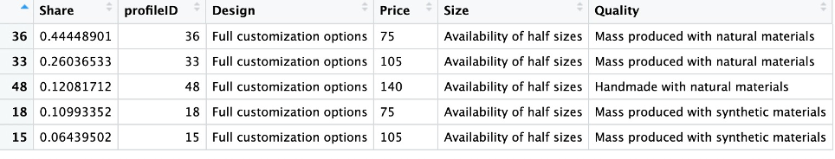

Communication strategy developed for Akuna

Lastly, in order to strengthen Akuna's presence in the market, we will now build a communication strategy for the brand. The initial phase involves an STP analysis to identify the target audience and the positioning to be followed. In a subsequent phase, we will formulate communication objectives that will serve as guidelines for subsequent strategies and action plans.

Segmentation

From the segmentation, we will proceed to divide the market into groups with similar characteristics and needs. Thus, it is necessary to define segmentation criteria to accurately identify the target audience.

**Sociodemographic Criteria:** This audience comprises end consumers located in the geographical area of Italy, specifically in the north and center of the country, aged between 14 and 60 years, predominantly male and with a monthly income above €1000.

**Geographic Criteria:** Customers from all segments are of various nationalities and cultures, with Italians being the predominant customers.

**Psychographic Criteria:** This audience consists of individuals directly or indirectly involved in the football universe, placing high value on the quality of football boots.

**Behavioral Criteria:** These customers tend to be loyal to a brand of football boots, approving and recommending it to others, becoming repeat customers. They prefer quality and are not sensitive to higher prices.

Target

Upon identifying the macro segments of Akuna, it is possible to define the target audience that makes the most sense and is most beneficial for the company's growth. In order to tailor the company's communication to the intended target, we conducted a brief analysis of the target audience that Akuna aims to reach. In the case of Akuna, target can be approached considering factors such as age, geolocation, and lifestyle.

Akuna primarily targets the end consumer market (B2C). However, the target audience can be subdivided into two categories:

1. **Football players in the 18-30 Age Bracket**: This target includes male players aged between 18 and 30, young adults with a substantial fixed income, whether they play professionally or not. They are primarily located in central and northern Italy and have internet access.
2. **Parents of football players:** This target focuses mainly on male or female consumers over 30 years old who are professionals working full-time with a monthly income above €1000. They are mostly parents of sub-18 football players who still finance their children's football equipment. In terms of location, they are also situated in Italy and have internet access.

Based on Akuna’s positioning as a high-quality Italian brand, we will now develop a brief social media strategy for Akuna. The communication strategy developed has been crafted with careful consideration of the company's positioning, guiding the communication in alignment with its essence and purpose.

Communication objectives

Through the current situational analysis of Akuna, we understand that one of the communications issues the company faces is a lack of brand awareness. Based on this, we will develop two main objectives.

The first objective is to **organically increase and enhance the company's online presence**. With this objective, we aim to boost brand visibility, expand the customer base, and consequently, foster brand loyalty.

The second objective is to establish **strategic partnerships with at least two consumers barter based**. With this objective, the company can associate its image with the football market through two players who may have the influence to impact other players in its online and in-person circle.

Therefore, with these two objectives, we consider both the organic communication efforts by the company and a partnership goal where consumers will promote the brand. We considered these objectives fit within the company's budget and align with the desired brand image.

Communication strategies

For the strategy developed based on the first objective of increasing and improving online presence, we have chosen to incorporate content marketing by creating relevant and engaging content for consumers related to the football universe. In this regard, we aim to use digital media to enhance not only the brand's image but also to increase interaction with consumers. For this strategy, we plan to use Instagram, where the company is already present, and, on the other hand, for content creation, we find it essential to establish a profile on the TikTok social media. In order to help the company grow organically, these materials will be centered around the SMM format, specifically in the form of posts, reals, and stories.

Media Action Plan

To increase and improve online presence, we believe it is necessary to create two content editorial themes for the mentioned channels (Instagram and TikTok).

* **"Akuna Behind the football boots" Editorial (Production Process):** Through digital media, the idea is to produce Reels-format videos showcasing the production process of Akuna's exclusive cleats, highlighting the details and step-by-step of the production, packaging, and delivery of the brand's products. Through this content, the company can demonstrate the delicacy, high-quality materials, and the italian artisanal process. This format is more suitable for TikTok, although it can also be shared on Instagram.
* **"Akuna Performance" Editorial (Performance Analysis):** In this section, in the form of photo or video posts, the company could develop a detailed analysis of the football boots performance in different conditions and describe the materials used.

An outlined strategy to achieve the second objective emphasizes the importance of establishing strategic partnerships with at least two consumers. Given the reluctance of the owner to pay for sponsorships, the selection of these partners aims to include partnerships based on exchanges with football players who are not widely recognized. With this strategy, the brand can operate on two fronts: the virtual component where these players will promote the brand on their social media platforms, but it can also boost the "in-person" aspect through WOM among individuals in the circles of these partners. Thus, this strategy is crucial for establishing a direct connection of the brand with its target audience, elevating its visibility.

To achieve this goal in the online realm, it is suggested that partners create two types of content:

* **Akuna Unboxing**: In this format, consumers can produce unboxing videos of the football boots, highlighting unique features and sharing their initial impressions.
* **Akuna's favorites:** In this editorial, players share their personal choices of Akuna products. Through these videos, players can explain their choices, providing a personal perspective on the company's products. This viewpoint creates a deeper connection with the target audience.

Main Project Take-Aways and Recommendations

Throughout our extensive research, we have pinpointed several meaningful insights that we believe could extensively benefit Akuna’s business strategy. However, we would like to also issue a disclaimer over our interpretations, given the limited resources for data collection. Nonetheless, we feel like the survey templates as well as statistical explorations are robust and can be utilized for larger-scale data collection and further analysis.

Firstly, one of the key conclusions we have reached is that Akuna has a very low brand awareness capital among the sampled respondents. We believe that Akuna needs to enhance its presence online, not only through producing more media content on their pages, but also publicizing honest and elaborate customer reviews. Akuna is perceived as a not trustworthy brand due to lack of information about it online as well as shallow market penetration, which implies the need of enhanced marketing strategies as natural spread of information through small-network social interaction (i.e. a friend’s recommendation) is not enough. We recommend following the Media Action Plan described in the report to ensure the attraction of new customers and enticing existing customers to purchase products via the freshly built marketplace website. Nearly all of the respondents expressed aversion towards purchasing unknown brand online without trying the shoes on first, so online campaigns would not likely bring more new online shoppers, but they could definitely make them more inclined to try on Akuna shoes if they see it in the store and hence consider it for purchase.

On a similar note, as online sales are likely to come from known customers and consolidate customer retention by offering an easier way of buying the product they like, it is also worth looking into partnerships with agents in the Southern Italy and increase market coverage there. This is because Southern Italy is known for deep admiration of football, and online research shows that Sicily and Apulia have some of the largest numbers of subscribers to the [National League of Amateur Football Players](https://lnd.it/it/la-lnd/i-numeri-del-calcio-dilettantistico) (Lega Nazionale Dilettanti), which seem to fit the profile of potential Akuna customers. Also, the same could be said about younger players, as per [FIGS’](https://www.figc.it/it/giovani/grassroots-attivit%C3%A0-di-base/sistema-qualit%C3%A0-club-giovanili/elenco-scuole-calcio-elite/?p=3) data about football clubs for children across Italy.

Also, according to the Conjoint results, respondents appeared to pay especial attention to the attributes related to comfort and quality of the shoes, while design and availability of half-sizes was deemed less significant. Additionally, they valued the *elite status* of a brand, but it seemed to be associated with widespread popularity of a shoe's producer rather than with use of premium quality materials and hand-made craftsmanship; specifically, brands worn by top-tier players such as Nike, Adidas or Puma. Therefore, it would be important to emphasize features related to comfort, quality, and local production since a lot of respondents of the second survey iteration shared the belief that Italian-made shoes are better than foreign ones.

Lastly, price has been proven to be a key driving factor in the decision making of potential consumers. Both Conjoint and Van Westendorp analysis pinpointed the reluctance to pay more than 100 EUR for a pair of shoes, no matter how amazing the quality could be. Precisely, 60 EUR was considered the optimal price lever, with 100 EUR being the upper limit beyond which most customers would lose interest in the product. It is important to pinpoint that most respondents were workers and self-classified their financial capabilities as ‘medium’, and we did not trace any correlation between self-reported wealth and usual price of shoes respondents purchased, which implies that even those who said they had low income were willing to purchase cleats from higher price ranges as long as it meant getting quality products. Nonetheless, the results of the Conjoint analysis once again emphasized that no matter the exceptional hand-made quality, customers would still stick to the threshold of no more than 100 EUR rather than splurge on more expensive shoe types. Therefore, perhaps, the prices on the marketplace should be reviewed and brought closer to the range for which Akuna’s shoes are sold at physical stores.

# **Bibliography**

Accessori. (n.d.). Ryal-Shop. Retrieved December 17, 2023, from <https://shop.ryal.it/accessori/>

Aglockhart. (2020, December 2). Pantofola D’Oro Lazzarini SL review. Lockhart Boot Blog. <https://lockhartbootblog.com/2019/09/28/pantofola-doro-lazzarini-sl-review/>

Akuna srl è valutata come “molto buono” con 4,1 / 5 su trustpilot. Trustpilot. (n.d.). <https://it.trustpilot.com/review/akuna.it>

Diadora: Scarpe, Abbigliamento e Accessori IT. (n.d.). Diadora. Retrieved December 17, 2023, from <https://www.diadora.com/it/it/?gad_source=1&gclid=CjwKCAiA1MCrBhAoEiwAC2d64fGlfFUj.OdCvOsuvxC5N7b4rrhL2Y5s0ZFm-iQAAokKEEngduxmT1BoCo5wQAvD_BwE&gclsrc=aw.ds>

Elenco Club Giovanili riconosciuti di 3°-2°-1° livello | FIGC. (n.d.). Federazione Italiana Giuoco Calcio | FIGC. <https://www.figc.it/it/giovani/grassroots-attività-di-base/sistema-qualità-club-giovanili/elenco-scuole-calcio-elite/?p=3>

Facebook Akuna srl. Facebook. (n.d.). <https://www.facebook.com/akunasrl/?locale=it_IT>

Football Boots | Made in Italy. (n.d.). Pantofola D’Oro. Retrieved December 17, 2023, from <https://www.pantofoladoro.com/collections/football-boots?page=5>

Google. (n.d.). Google search. <https://www.google.com/search?sca_esv=586327572&sxsrf=AM9HkKlHrINh-CmoZDmBDtX8MllMMz9GUw%3A1701280206242&uds=H4sIAAAAAAAA_-PS5mIPSi3LTC0vFpJLzC7NS1QoTk4sKkhVKC7KUUhOzEnOzFcoAiswYBbi4mIQYpBiUGLQYAAA5ywgcDkAAAA&si=ALGXSlbXm0uZkOvwvL0f1xrkn2WL71XYlO7Pt_7-_Cecra_WQHep4vRmdMa5MmolkBb01y8oHwq5GhRlcXbPAULh7bVX-3UTxe4mioU3zeUQ3dCVqLLgB0Q%3D&q=Akuna%2BS.r.l.%2BReviews&sa=X&ved=2ahUKEwiv0OzS4umCAxV80gIHHd3JAZoQ3PALegQIVxAF>

I numeri del calcio dilettantistico. (n.d.). Lega Nazionale Dilettanti. <https://lnd.it/it/la-lnd/i-numeri-del-calcio-dilettantistico>

Opinions on the pantofola D’oro Lazzarini : R/bootroom - reddit. (n.d.). <https://www.reddit.com/r/bootroom/comments/vh9tpj/opinions_on_the_pantofola_doro_lazzarini/>

WebAsk. (n.d.). Scarpe da Calcio. Silei Sport. Retrieved December 17, 2023, from <https://www.sileisport.it/prodotti/scarpe>

YouTube. (2014, February 25). Akuna Cinquestelle Colibri - unboxing + on feet. YouTube. <https://www.youtube.com/watch?v=6nukL1ou3Js&t=463s>

YouTube. (2017, December 23). Lightest cleats ever! - pantofola d’oro superleggera - review + on feet. YouTube. <https://www.youtube.com/watch?v=ZeYuYkRtqRk>

1. In the original: *“L’ idea che ancora oggi vogliamo trasmettere è quella del prodotto artigianale di eccellenza, creato da pellami di prima qualità, da materiali scelti nel nostro distretto calzaturiero e, soprattutto la manualità del procedimento di creazione che rende il nostro prodotto unico.”*
2. Chapman, C., & Feit, E. M. (2015). R for marketing research and analytics (Vol. 67). New York, NY: Springer.